

Practices for Secure Software Report

Table of Contents
Document Revision History 3
Client 3
Instructions 3
Developer 4
1. Algorithm Cipher 4
2. Certificate Generation 4
3. Deploy Cipher 4
4. Secure Communications 4
5. Secondary Testing 4
6. Functional Testing 4
7. Summary 4
8. Industry Standard Best Practices 4

Document Revision History

Version | Date | Author | Comments
1.0 | 10/18/2026 | Preston Mesecher

Client



Instructions

Submit this completed practices for secure software report. Replace the bracketed text with the relevant information. You must document your process for writing secure communications and refactoring code that complies with software security testing protocols.

- Respond to the steps outlined below and include your findings.
- Respond using your own words. You may also choose to include images or supporting materials. If you include them, make certain to insert them in all the relevant locations in the document.
- Refer to the Project Two Guidelines and Rubric for more detailed instructions about each section of the template.

Developer
Preston Mesecher

Algorithm Cipher

One way to help protect Artemis Financial's information is by using SHA-256. This creates a 256-bit hash that can be used to check if data has been changed. It does not use symmetric or asymmetric keys because it is used for hashing rather than encryption. The application will also use HTTPS and a certificate to help protect information being sent between the user and the application. These changes will help improve security and protect customer information.

Certificate Generation
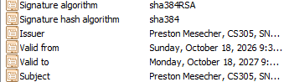

Deploy Cipher

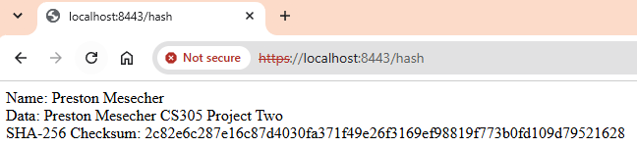

Secure Communications
I updated the application properties to use HTTPS instead of HTTP. I also added the keystore information so the application could use the certificate I created. After making these changes I ran the application and opened https://localhost:8443/hash. The webpage displayed my name and the SHA-256 checksum. This showed that the application was running through HTTPS. The browser still showed a security warning because the certificate was self-signed and was not trusted by the browser.
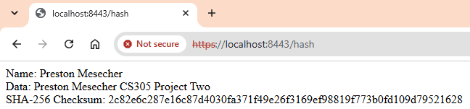

Secondary Testing

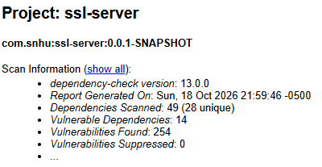
The dependency check scanned 49 dependencies and found 254 reported vulnerabilities across 14 dependencies. No vulnerabilities were suppressed. The scan completed successfully but the findings show that some dependencies still have security issues that need to be reviewed.

Functional Testing
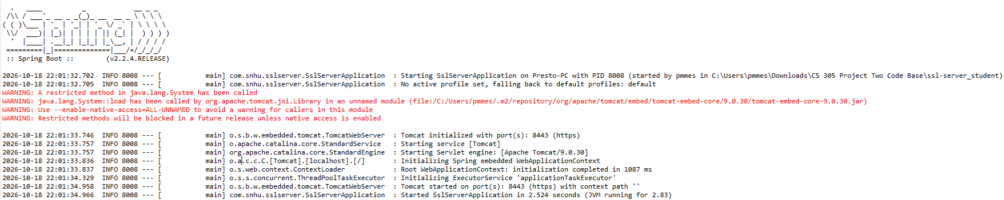
I reviewed the code to check for any syntax, logic, or security issues. I checked that the SHA-256 checksum was set up correctly and that the application was using HTTPS. After running the application I was able to open the webpage and see my name along with the checksum. The application started without errors and the changes I made were working as expected.

Summary

The changes I made to Artemis Financial's application helped improve its security. I added SHA-256 to create a checksum that can be used to check if data has been changed. I also created a self-signed certificate and updated the application to use HTTPS instead of HTTP. After making these changes I tested the application to make sure it was running correctly. I also ran a dependency check which found vulnerabilities in some of the application's dependencies. These changes added more security by helping protect communications and providing a way to verify data.

Industry Standard Best Practices

Some of the security practices I used in this project included SHA-256 hashing, HTTPS, and a self-signed certificate. SHA-256 was used to create a checksum to help identify changes in data. HTTPS was used to help protect information being sent between the application and the browser. I also used the dependency-check tool to scan for security vulnerabilities. The scan found vulnerabilities in several dependencies that would need to be reviewed. These practices helped improve the security of the application and identify areas that still need attention.

